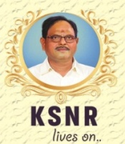
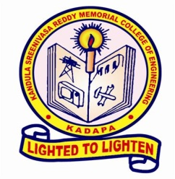
K.S.R.M. COLLEGE OF ENGINEERING
(UGC- AUTONOMOUS)
Kadapa,Andhra Pradesh, India– 516 003
Approved by AICTE, New Delhi & Affiliated to JNTUA, Ananthapuramu.

Activity Report
Name of the Activity | “ COMPUTER SOCIETY OF INDIA (CSI) chapter” Inauguration
Type of Activity | Inauguration Program
Date and Time of Activity | 24th February, 2022 | 10.00 am to 12.00 pm
Details of Participants | B.Tech Students from CSE
Coordinator(s) | Sri. Ram Prakash Reddy, B. Swetha Reddy , S. Nadiya, Asst Professor, Dept., of CSE, KSRMCECE, Kadapa
Organizing Dept./Support System | Department of CSE
Description | The CSI chapter at KSRMCECE for the department of CSE was inaugurated on March 24, 2022 by Dr. K. Chandra Obul Reddy, Managing Director, Kandula Group of Institutions, along with V.S. Srinivasa Murthy, Principal, KSRMCE, and Dr. V. Lokeswara Reddy, HOD, CSE. This occasion was graced by Mr. C. Sudhakar, CSI Treasurer. After lighting the lamp, Dr. K. Chandra Obul Reddy, Managing Director, KSRMCE, welcomed everybody and he stressed the need for students to associate themselves with organisations like the Computer Society of India. Mr.C.Sudhaka, CSI Treasurer, spoke about the different activities of CSI. He stressed the need to organise various events related to CSI, such as tutorials, seminars, conferences, etc., for the benefit of the student and faculty community.
Photos | 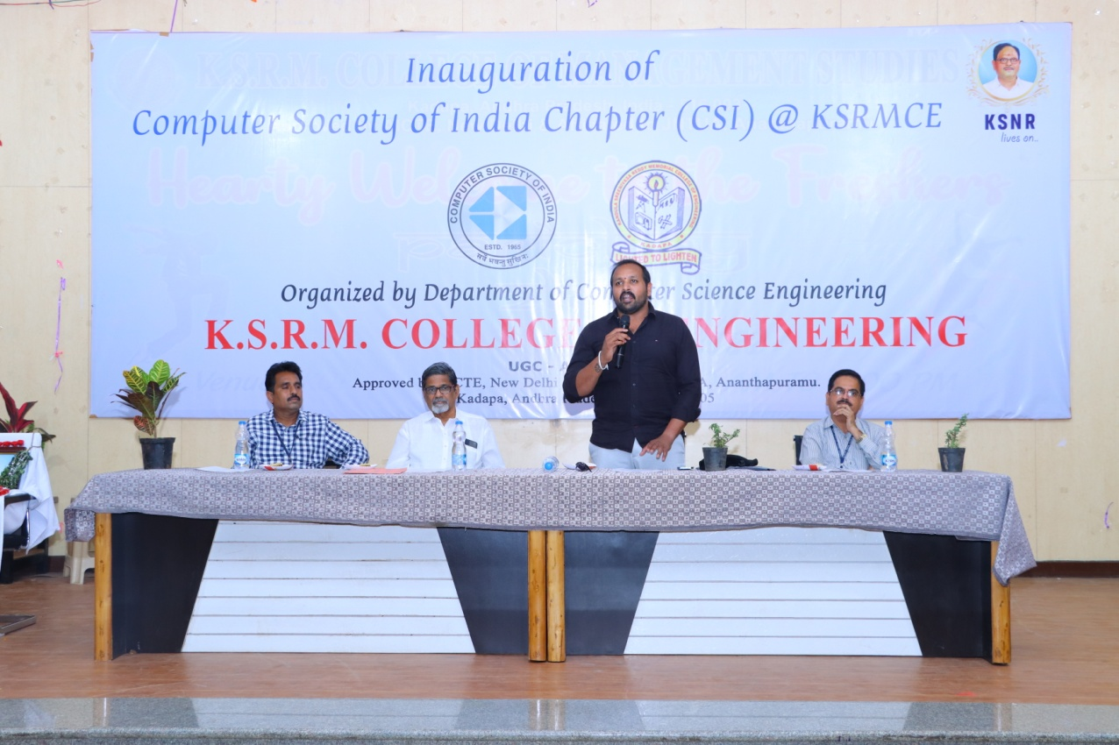  MANAGING DIRECTOR ADDRESSING TO STUDENTS 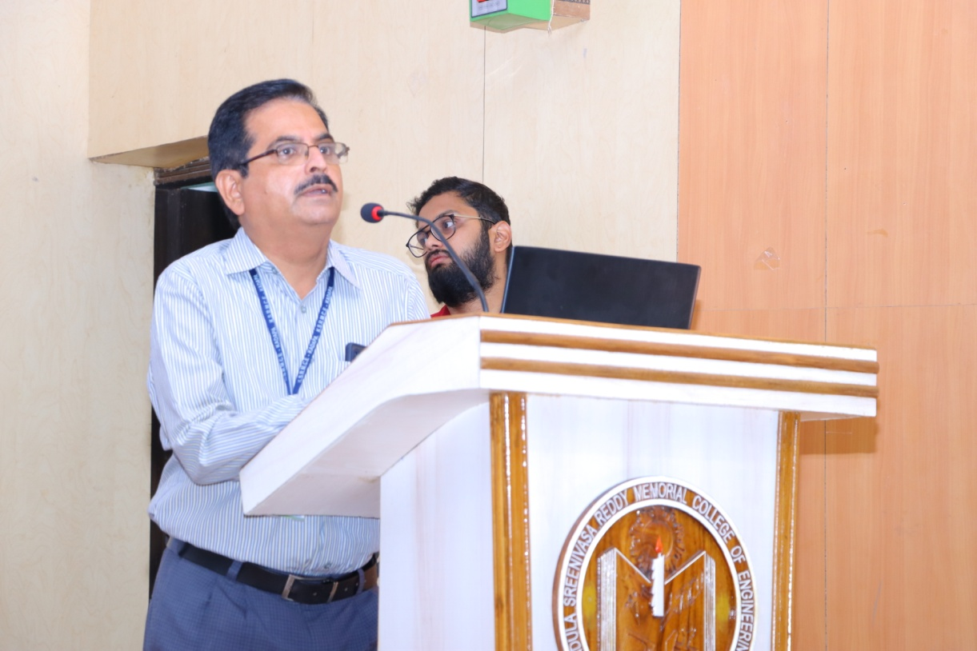  PRINCIPAL ADDRESSING TO STUDENTS  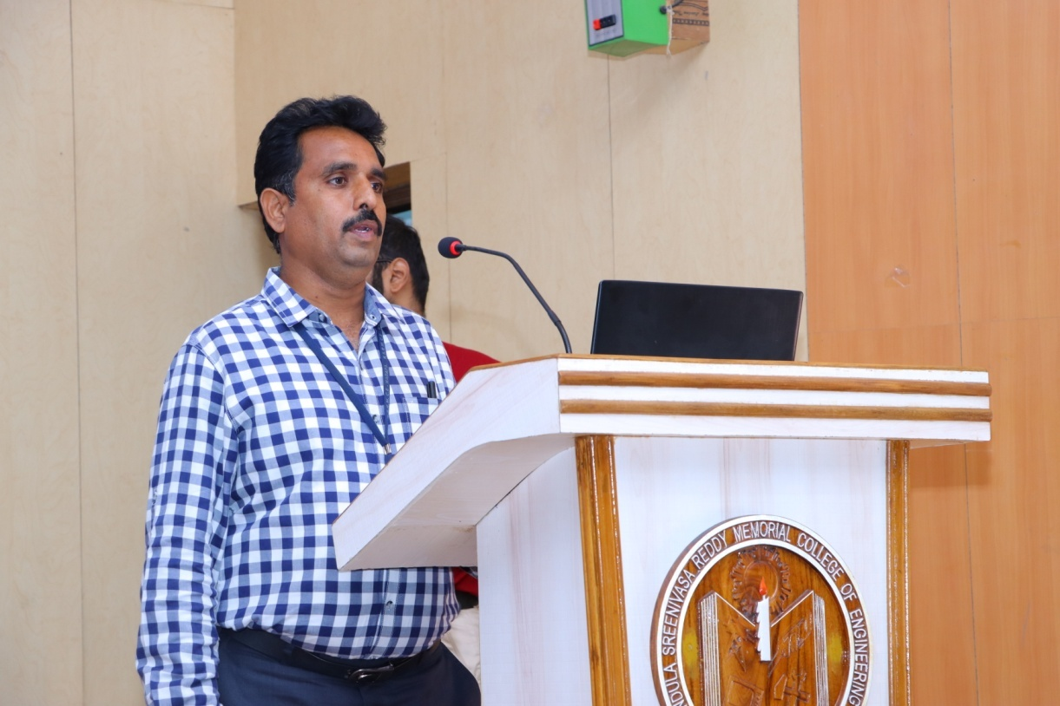  HOD ADDRESSING TO STUDENTS 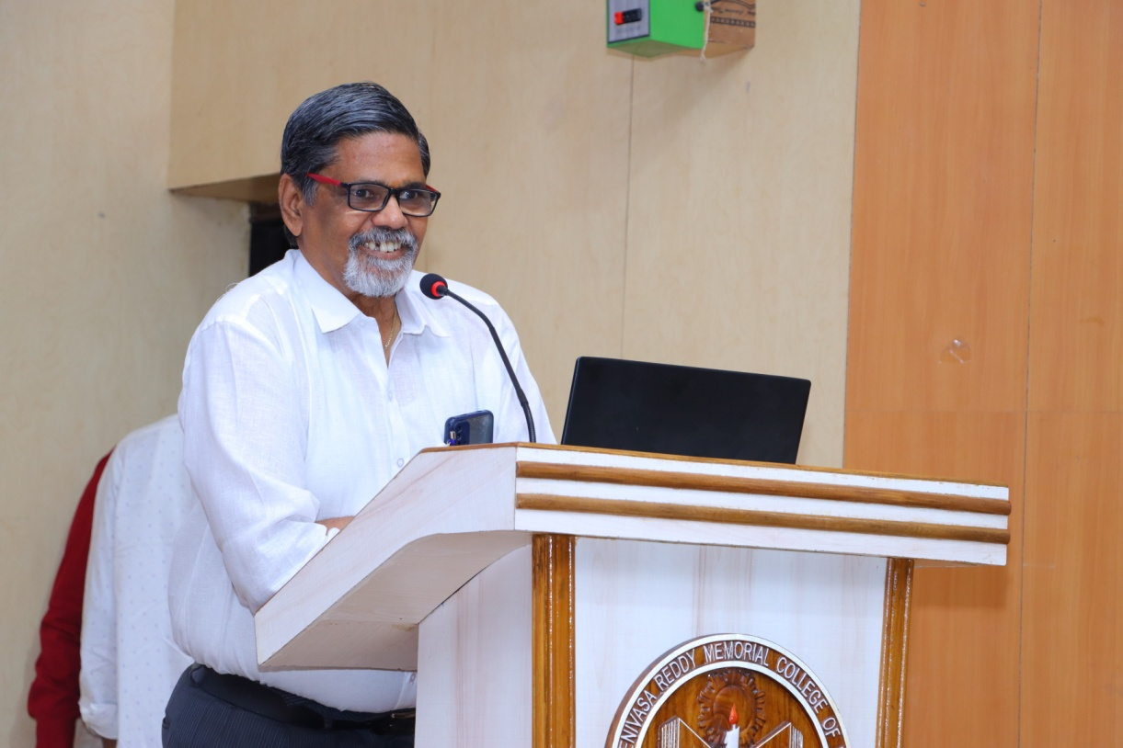  CHIEF GUEST ADDRESSING TO STUDENTS  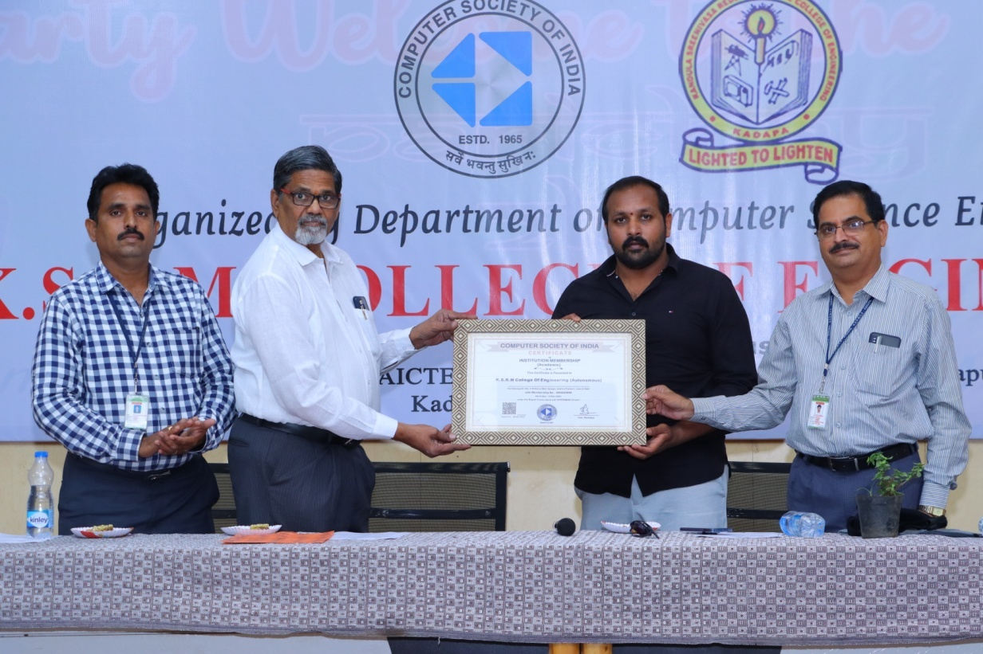  CSI CHAPTER INAUGURATION  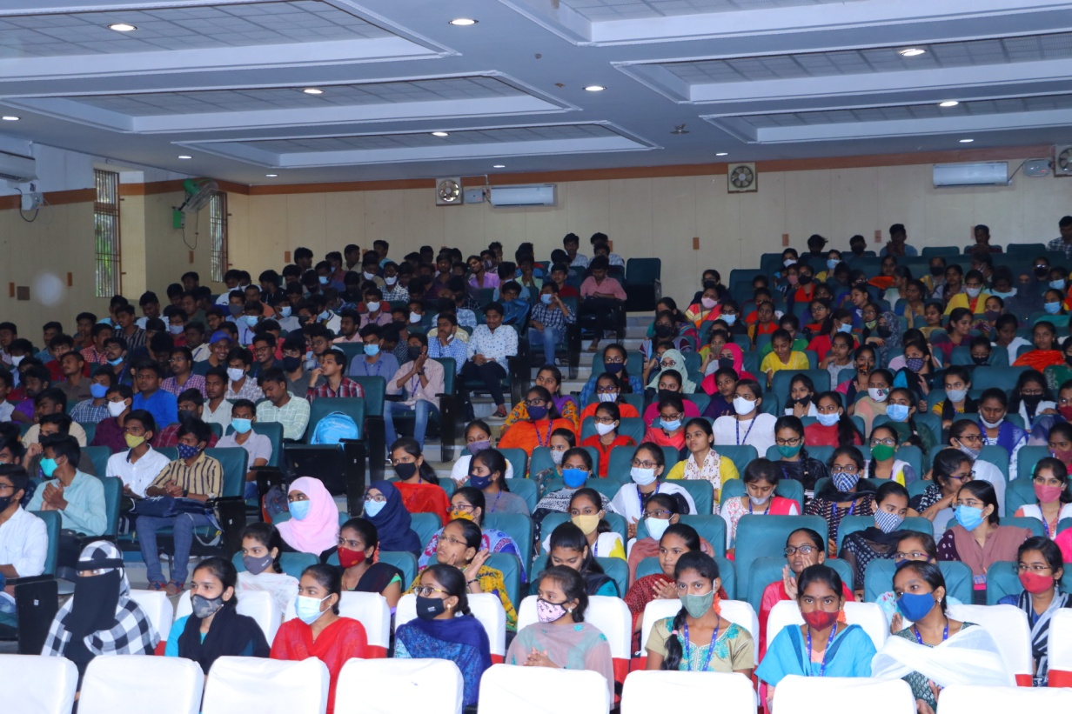  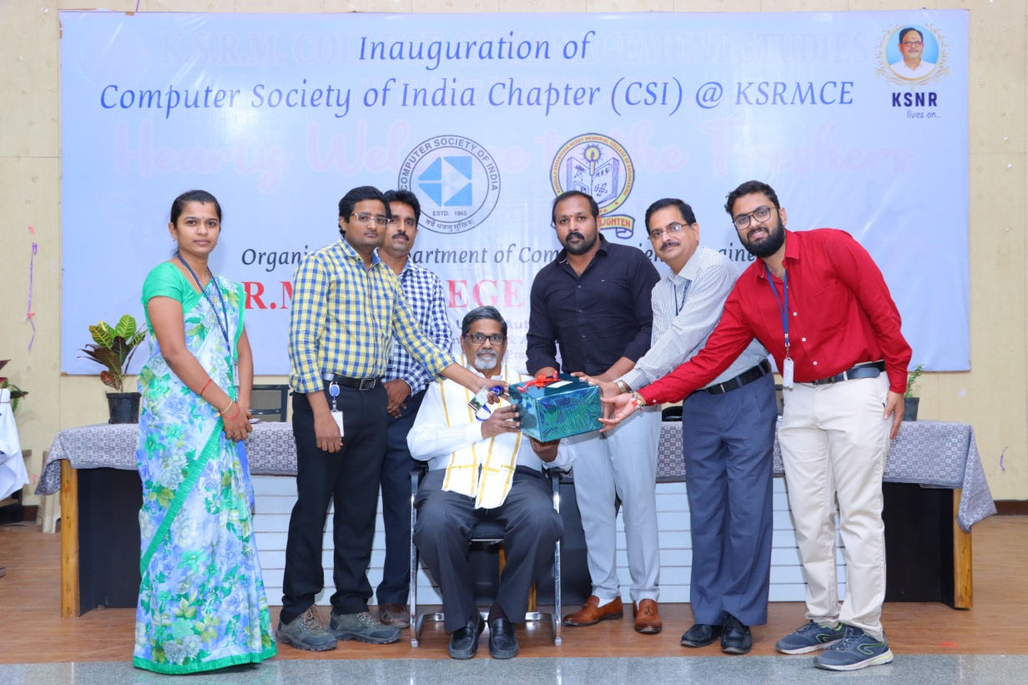  FELICITATING CHIEF GUEST

Coordinators Principal

